**SPRAWOZDANIE**

Zajęcia: Analiza Procesów Uczenia

Prowadzący: prof. dr hab. Vasyl Martsenyuk

**Laboratorium 2.2**

**Temat:** "Podatawy języka R"

**Wariant 1**

Maciej Wojcieszyk

Informatyka II stopień,

stacjonarne (zaoczne),

1 semestr,

Gr.:1

1. **Polecenie:**

Na podstawie metody MMOORA [? ] podja ̨ ́c decyzje ̨ o kupowaniu smartfonu Samsung z systemem Android 6, o ́smioкdzieniowym procesorem, z najwie ̨kszym wy ́swietlaczem, najwie ̨ksza ̨ pamie ̨cia ̨ RAM i pamie ̨cia ̨ wbudowana ̨, najwie ̨kszym aparatem foto za najmniejsza ̨ cenę Komunikacja (wifi itp) nie ma znaczenia. Dane (10 smartfon ́ow) pobra ́c ze strony

1. **Wprowadzane dane:**

"0","model","pamiec_RAM","pamiec_wbudowana","aparat_foto","cena","liczba_opinii","ocena","status_opini"

"1","Xiaomi Mi Mix 3","6GB","128GB","12 Mpix + 12 Mpix",2699,0,0,"Nie ma"

"2","Samsung Galaxy A9","6GB","128GB","24 Mpix + 8 Mpix + 10 Mpix + 5 Mpix",1990,7,5,"Mniej niz 50 opini"

"3","Xiaomi MI 8 Lite","4GB","64GB","12 Mpix + 5 Mpix",1099,29,5,"Mniej niz 50 opini"

"4","Honor 8X","4GB","128GB","20 Mpix + 2 Mpix",1299,396,5,"Wiecej niz 100"

"5","Huawei P20","4GB","64GB","20 Mpix + 12 Mpix",1799,11,5,"Mniej niz 50 opini"

"6","Huawei P20 Lite","4GB","64GB","16 Mpix + 2 Mpix",1099,179,5,"Wiecej niz 100"

"7","Samsung Galaxy A7","4GB","64GB","24 Mpix + 5 Mpix + 8 Mpix",1399,18,5,"Mniej niz 50 opini"

"8","Honor 9 Lite","3GB","32GB","13 Mpix + 2 Mpix",749,53,5,"Miedzy 50 a 100"

"9","Huawei P20 Pro","6GB","128GB","40 Mpix + 20 Mpix + 8 Mpix",2699,72,5,"Miedzy 50 a 100"

"10","Xiaomi Redmi 6","3GB","32GB","12 Mpix + 5 Mpix",599,25,5,"Mniej niz 50 opini"

"11","Motorola Moto G6 Play","3GB","32GB","13 Mpix",669,304,5,"Wiecej niz 100"

"12","Huawei Y7 Prime 2018","3GB","32GB","13 Mpix + 2 Mpix",699,23,5,"Mniej niz 50 opini"

"13","Huawei Mate 20 Lite","4GB","64GB","20 Mpix + 2 Mpix",1399,17,5,"Mniej niz 50 opini"

"14","Honor 10","4GB","64GB","24 Mpix + 16 Mpix",1599,34,5,"Mniej niz 50 opini"

"15","Samsung Galaxy A6+","3GB","32GB","16 Mpix + 5 Mpix",999,28,5,"Mniej niz 50 opini"

1. **Wykorzystane komendy:**

library("MCDM")

lodowki <- read.csv("smartfony.csv")

d <- matrix(c((lodowki$pamiec_RAM), c(lodowki$pamiec_wbudowana), c(lodowki$cena)), nrow = 15, ncol = 3)

w <- c(1 / 3, 1 / 3, 1 / 3)

cb <- c("max", "min", "min")

MMOORA(d, w, cb)

1. **Wyniki działań:**

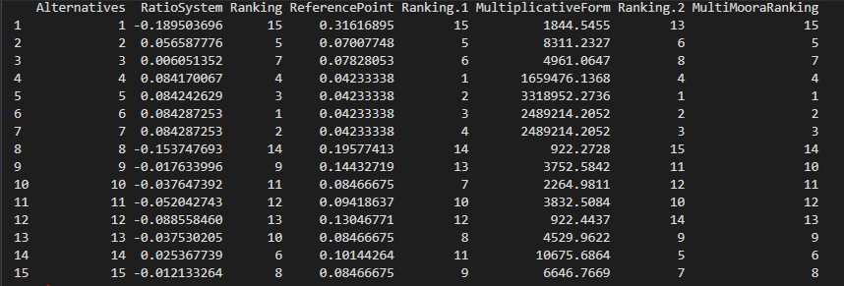

1. **Wnioski:**

Po zastosowaniu metody MCDM, możemy jednoznacznie stwierdzić króry smarfon wypada najlepiej.